Prompt：Current Task Material Information:
- Material Name: Green-rimmed storage bin
- Starting Location: Pick Station 1
- Target Location: Place Station 3
- Quantity to Transport: 1

JCIIOT 2026 Standard Operating Procedure (SOP)
Electronics Factory Material Handling Work Instruction
Document Number: SOP-ELC-001-2026-IND
Version: 1.0
Release Date: April 23, 2026
Scope: Electronics Factory Material Handling Operations
Prepared By: Production Operations Department
Reviewed By: Quality Management Department
Approved By: Factory Manager

1. Purpose and Scope
1.1 Purpose
This Standard Operating Procedure aims to standardize the material handling operations within the electronics factory, ensuring that operators perform material transfer tasks according to unified standards, guaranteeing operational safety, improving efficiency, and reducing material loss.
1.2 Scope
This procedure applies to all activities within the electronics factory involving the transportation of materials from designated pick stations to designated place stations.

2. Responsibilities and Authorities
2.1 Operator Responsibilities
- Strictly execute material handling operations in accordance with this SOP.
- Ensure the safety and accuracy of materials during the handling process.
- Promptly report abnormal situations during operations.
- Record operational data and submit operation reports.
2.2 Site Supervisor Responsibilities
- Supervise operators to perform tasks according to the procedure.
- Handle abnormal situations during operations.
- Review operation records.

3. Pre-Operation Preparation
3.1 Material Identification and Confirmation
Operation Requirements:
- Confirm the type, specification, and quantity of materials to be handled according to the production task order.
- Verify the information on the material identification cards.
- Confirm that the material appearance is intact, without damage or contamination.
3.2 Equipment and Tool Inspection
- Check that the handling equipment functions normally.
- Confirm that the gripping device is in good working condition.
- Verify the accuracy of the navigation system.
3.3 Work Environment Confirmation
- Check that the work aisles are clear and unobstructed.
- Confirm that lighting conditions meet operational requirements.
- Identify potential safety hazards.

4. Standard Operating Procedure
4.1 Phase One: Move to Pick Station
Operation Steps:
Step 1.1 - Receive Operation Instructions
- Confirm task order information.
- Record task start time.
- Set navigation target: Pick Station.
Step 1.2 - Navigate to Pick Station
- Start the navigation system.
- Move along the planned path.
- Maintain a safe driving speed.
- Enter standby mode upon arrival.
Step 1.3 - Work Area Confirmation
- Visually inspect the area around Pick Station 1.
- Confirm sufficient workspace.
- Verify material location.

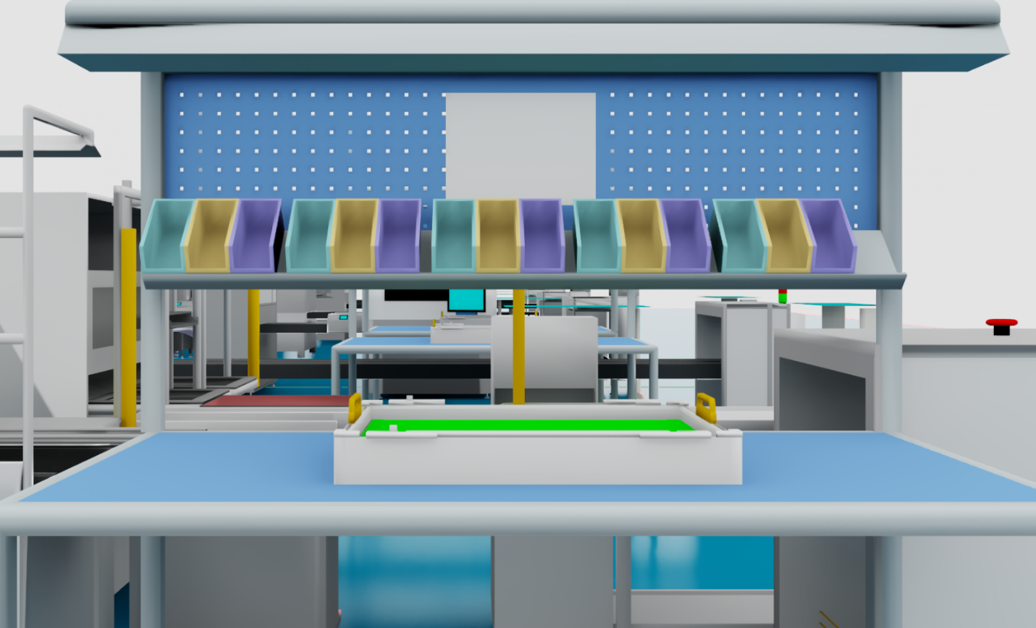

4.2 Phase Two: Material Picking Operation
Operation Steps:
Step 2.1 - Material Positioning
- Activate the visual recognition system.
- Precisely locate the target material (blue hollow plastic bin).
- Confirm material orientation and picking conditions.
Step 2.2 - Picking Path Planning
- Calculate the optimal picking trajectory.
- Detect surrounding obstacles.
- Ensure the picking path is safe.
Step 2.3 - Execute Picking Action
- Move the gripping device to the predetermined position.
- Execute picking at a standard speed.
- Apply appropriate clamping force (avoid material deformation).
- Confirm successful picking signal.
Step 2.4 - Picking Status Verification
- Check the stability of material clamping.
- Confirm no material displacement.
- Record picking completion time.
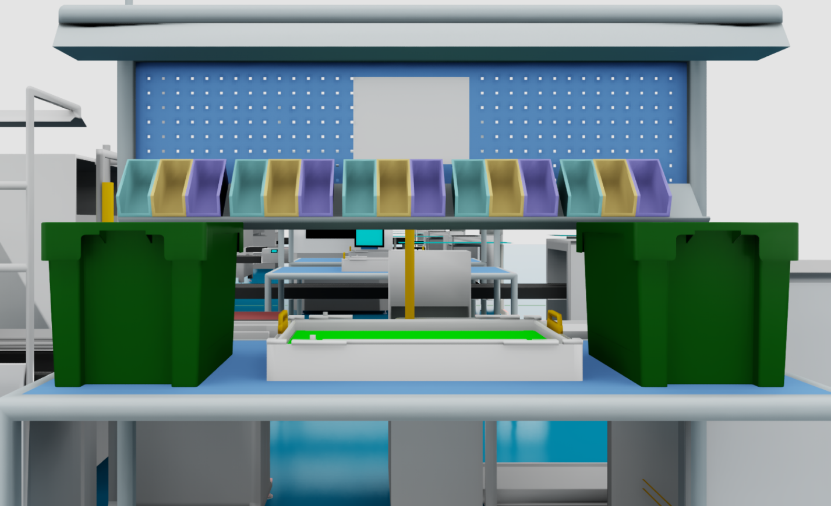

4.3 Phase Three: Material Transfer and Transportation
Operation Steps:
Step 3.1 - Transportation Path Planning
- Access factory map data.
- Calculate the optimal path from Pick Station 1 to Place Station 3.
- Consider comprehensively:
  - Shortest path length.
  - Highest safety factor.
  - Avoidance of restricted areas.
Step 3.2 - Execute Transportation Operation
- Start the navigation system.
- Maintain material stability.
- Real-time monitoring of:
  - Material clamping status.
  - Changes in the surrounding environment.
  - Equipment operating parameters.
Step 3.3 - Dynamic Obstacle Avoidance
- Activate the obstacle detection system.
- Upon detecting an obstacle:
  - Decelerate or stop.
  - Re-plan the path.
  - Select a safe detour plan.
- Ensure no collision or shaking of materials.
Operation Standards:
- Transportation Speed: Complies with safety regulations.
- Material Stability: No significant shaking.
- Number of Collisions: Zero tolerance.
Factory Map:
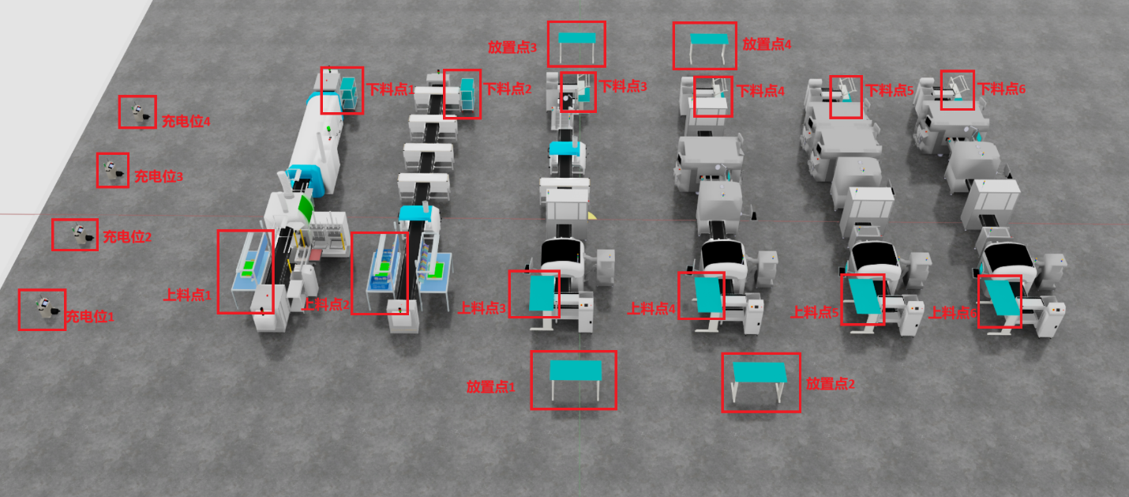
4.4 Phase Four: Material Placement Operation
Operation Steps:
Step 4.1 - Arrive at Place Station 3
- Navigate to the designated position at Place Station 3.
- Enter placement operation mode.
- Perform environmental scan after stopping.
Step 4.2 - Placement Area Confirmation
- Inspect the placement area at Place Station 3.
- Confirm no other materials are occupying the space.
- Confirm sufficient placement space.
Step 4.3 - Precise Placement
- Locate the target placement point.
- Plan the placement trajectory.
- Lower the material at a steady speed.
- Ensure the material makes full contact with the placement surface.
Step 4.4 - Release and Verification
- Slowly release clamping force.
- Confirm material is stably placed.
- Check the accuracy of the material's position.
- Material is not tilted, not exceeding boundaries.
Step 4.5 - Withdraw from Work Area
- Return the gripping device to its initial position.
- Exit the Place Station 3 work area.
- Record placement completion time.
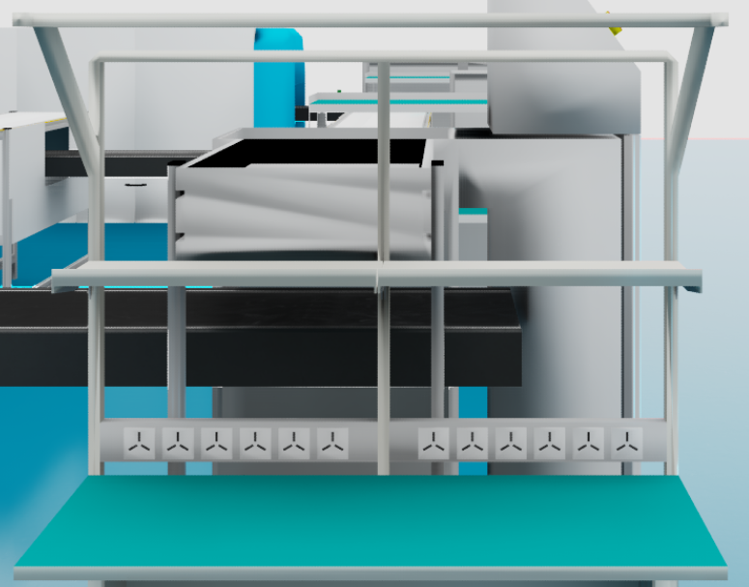
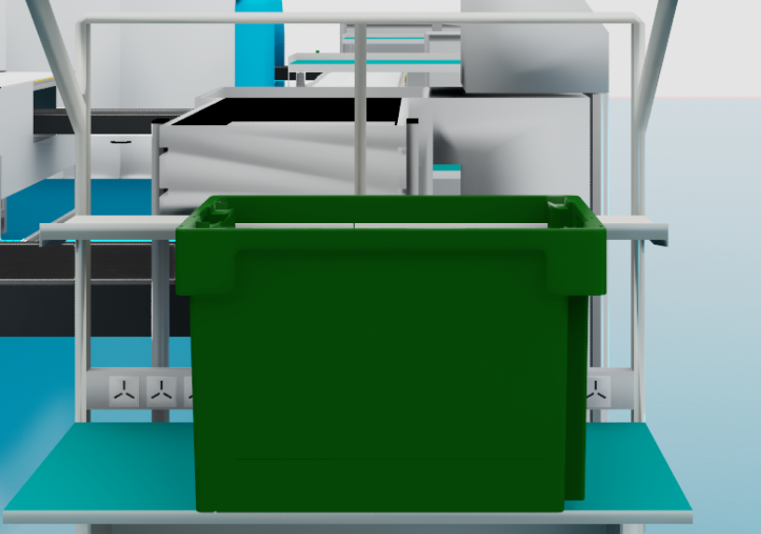

4.5 Phase Five: Cyclic Operation (if applicable)
Operation Condition: When the task order requires handling multiple items.
Operation Steps:
- Return to Step 4.1 and repeat Phases Two through Four.
- Each cycle must fully execute all verification steps.
- Record the completion status of each transfer.

4.6 Phase Six: Task Completion and Return to Home
Operation Steps:
Step 6.1 - Task Completion Confirmation
- Verify the quantity transported against the task order requirements.
- Confirm all materials have been correctly placed.
- Check for any missing materials.
Step 6.2 - Data Recording
- Record task completion time.
- Fill in the operation record sheet.
- Record abnormal situations (if any).
Step 6.3 - Equipment Return to Home
- Navigate to the designated standby area.
- Enter standby mode.
- Await the next operation instruction.

5. Anomaly Handling Procedures
5.1 Collision Event Handling
Handling Procedure:
- Immediate Stop - All movements cease immediately.
- Assess Damage - Check equipment and material status.
- Record Event - Fill out an anomaly report form.
- Report to Supervisor - Immediately notify the site supervisor.
- Await Instructions - Continue or stop operations based on supervisor's instructions.
5.2 Material Drop Handling
Handling Procedure:
- Stop Operation - Suspend the current transfer task.
- Assess Situation - Determine if safe re-grasping is possible.
- If Conditions Allow - Perform re-grasping operation.
- If Conditions Do Not Allow - Report anomaly, await manual handling.
- Record Event - Fill out an anomaly report form.
5.3 Path Obstruction Handling
Handling Procedure:
- Stop Advance - Stop at a safe distance.
- Re-plan - Calculate an alternative path.
- Cannot Detour - Report anomaly, await obstacle clearance.
- Resume Operation - Continue after obstacle is cleared.
5.4 SOP Discrepancy with Reality
Handling Procedure:
- Immediately stop operations.
- Report to the site supervisor.
- Describe discrepancies in detail.
- Await SOP update or special instructions.
- Do not unilaterally change operational procedures.

6. Safety Precautions
6.1 General Safety Requirements
- Always comply with factory safety regulations during operations.
- Do not overspeed or perform dangerous maneuvers.
- Maintain a clean and orderly work area.
6.2 Material Safety
- Avoid material collision, dropping, or damage.
- Ensure material remains stable during transport.
- Do not overload or improperly grasp.
6.3 Environmental Safety
- Be aware of surrounding personnel and equipment.
- Maintain safe distances.
- Comply with factory traffic rules.

7. Quality Standards
7.1 Operation Quality Indicators
- Material Intact Rate: 100%
- Placement Accuracy Rate: 100%
- Operation Safety Rate: 100%
- Path Optimization Rate: ≥95%
7.2 Time Efficiency Requirements
- Single Transfer Operation Time: Complies with standard man-hours.
- Anomaly Downtime: Minimized.

